

**DEPARTMENT OF ELECTRICAL AND ELECTRONICS ENGINEERING**

**ULTRASONIC RANGE FINDER USING ARDUINO**

A MINI PROJECT REPORT

***Submitted by***

*VIKRAM.S (1NH18EE061)*

*JIBRAN ZAIDI HUSSAIN.C (1NH18EE022)*

*NIRUPAVARDHAN REDDY (1NH18EE027)*

***In partial fulfillment for the award of the degree of***

**BACHELORS OF ENGINEERING**

**IN**

**ELECTRICAL AND ELECTRONICS ENGINEERING**



**DEPARTMENT OF ELECTRICAL AND ELECTRONICS ENGINEERING**

**BONAFIDE CERTIFICATE**

This Certificate that Mini project work entitled **“ULTRASONIC RANGE FINDER USING** **ARDUINO”** Carried out by **VIKRAM.S–1NH18EE061**, **JIBRANZAIDI HUSSAIN–1NH18EE022, NIRUPAVARDAN REDDY-1NH18EE027** are Bonafide students of New Horizon college of Engineering submitted the report in completion of project at Department of Electrical and Electronic Engineering during Academic Year 2019-20. It is Certified that all the Corrections/Suggestions indicated for Internal Assessment have been incorporated in the report deposited in the department library. The project report has been approved as it satisfies the academic requirements in respects of Project work prescribed for said Degree.

Signature of GuideSignature of HOD

**(Mrs.DEEPA V BOLANAVAR) (Dr.RAMKUMAR.S)**



**Acknowledgement**

With immense pleasure and deep sense of gratitude, I wish to express my sincere thanks to my supervisor **Mrs**.**Deepa V Bolanavar ,** Head of the Department, Electrical and Electronics Engineering, New Horizon college of Engineering, without his motivation and continuous encouragement, this mini project would not be have been successfully completed.

It is indeed a great pleasure to recall the people who have helped us in carrying on this project Naming all the people who have helped us in achieving this project would be impossible, Yet I thank a selected few who have helped me in diverse ways.

We wish to excess our sincere gratitude to Dr.Manjunatha, Principal, NHCE, Bangalore for providing me with facilities to carry out this project.

We wish to express our sincere gratitude to our teacher and guide Dr Ram Kumar (HOD) NHCE for his valuable suggestions, guidance, care and attention shown during the planning, Conduction stage of this project work.

We express our sincere thanks to project coordinator, all the staff members and non-teaching staff of Department of Electrical and Electronic Engineering for the kind of cooperation extended by them.

**ABSTRACT**

This project presents a rangefinder using 8051microcontroller on Arduino Uno. Here, we have made our project based Ultrasonic range finding Sensor on Arduino to measure the distance of an object. It is measured using pulse echo method. The ultrasonic module transmits a signal to the object, then receives echo signal from the object and produces output signal where time period is proportional to the distance of the object. This circuit calculate the distance of the object based on the speed of the sound wave at normal temperature and displays the distance on LCD. The project aims at designing a system, which is user friendly, easy to setup, eco-friendly, effectively and very useful. The mechanism of the ultrasonic sensor is similar to the RADAR (Radio Detection and Ranging). Ultrasonic rangefinder can find the distance between an object from itself using ultrasonic sensor. HC-SR04 Ultrasonic Module works on the principle of SONAR and is designed to measure the range of the object in small embedded projects. It offers excellent range detection black material. The ultrasonic rangefinder can measure up to 2.5 meters at accuracy of 1cm. AT89S51 microcontroller and the ultrasonic transducer module HC SR04 forms the basis of circuit. The objective of this research work is to measure the obstacle distance from reference. The system used in automotive parking sensor and obstacles warning systems can be used in terrain monitoring robots. This circuit has various application projects like automotive parking sensors, obstacle warning systems, traction control ling system, distance measurements etc. This sensor HC SR-904 has stable performance and high ranging accuracy that makes it a popular module in electronics market. Compared to the Sharp IR ranging module, But it has the same ranging accuracy and longer ranging distance.

**GROUP MEMBERS:**

**NIRUPAVARDHAN REDDY**

**JIBRAN ZAIDI HUSSAIN.C**

**VIKRAM.S**

Pg.no 1

**TABLE OF CONTENTS**

**ABSTRACT**……………………………………………………………….. **1**

**LIST OF FIGURES**…….…………………………………………………. **2**

**INTRODUCTION**……………………………………………………….... **3**

**THEORY OF OPERATION AND CONSTRUCTION**

WORKING OF ULTRASONIC RANGE FINDER……………………………………... **4**

BLOCK DIAGRAM……………………………………………………………………... **5**

WORKING OF ULTRASONIC SENSOR………………………………………………. **6**

ULTRASONIC DISTANCE MEASUREMENT………………………………………... **7**

**COMPONENTS AND PARTS**

HC-SR04 MODULE……………………………………………………………………. **8**

DHT11 HUMIDITY SENSOR…………………………………………………………. **9**

BREADBOARD………………………………………………………………………… **10**

LCD DISPLAY…………………………………………………………………………. **11**

LCD OUTPUT…………………………………………………………………………... **12**

**SOFTWARE**

ALGORITHM…………………………………………………………………………… **13**

TINKERCAD TOOL……………………………………………………………………. **14**

**APPLICATION AND ADVANTAGES**…………………………………. **15**

**CONCLUSION**…………………………………………………………… **16**

**REFERENCE**……………………………………………………………... **17**

Pg.no 2

**List of Figures:**

|  |  |  |
| --- | --- | --- |
| Sl.No | Name of the figure | Page No |
| Fig 1 | Ultrasonic sensor diagram | 6 |
| Fig 2 | Circuit connection | 6 |
| Fig 3 | Ultrasonic Sensor | 7 |
| Fig 4 | Speed of sound | 8 |
| Fig 5 | Spare parts | 9 |
| Fig 6 | HC-SR04 Module | 10 |
| Fig 7 | DHT11 Humidity Sensor | 11 |
| Fig 8 | Breadboard | 11 |
| Fig 9 | LCD Display | 12 |
| Fig 10 | Ultrasonic range finder Circuit | 13 |
| Fig 11 | Interfacing Ultrasonic with LCD | 15 |

Pg.no 3

**INTRODUCTION**

These Ultrasonic Range Finders are fun little module and the device too, that used to find distance from a point to the nearest obstacle using an ultrasonic transducer. It converts electrical energy into ultrasound, or sound waves above the normal range of human hearing. This device uses Ultrasonic technology to measure the distance. We can use them to find the distance to an object, or to detect when something is near the sensor like a motion detector. They are ideal for projects involving navigation, object avoidance, and home security. Because they use sound to measure distance, they work just as well in the dark as they do in the light. Which can measure from range of 2cm up to 400cm with an accuracy of 3mm. This report shows us to make three different range finder circuits for the Arduino. The first finder circuits is easy to set up, and has pretty good accuracy. The other two are bit more complicated, but are a bit more accurate because they factor in temperature and humidity.

It is reliable in any lighting environment and can be used inside or outside. Ultrasonic sensors can handle collision avoidance for a robot, and being moved often, as long as it isn’t too fast. Ultrasonic are widely used, they can be reliably implemented in grain bin sensing applications, water level sensing, drone applications and sensing cars at our local drive-thru restaurant or bank. These sensors are superior to infrared sensors because they are not affected by smoke or black materials, however, soft materials which don’t reflect the sonar (ultrasonic)waves very well may cause issues. It is not a perfect system, but is good and reliable.

Pg.no 4

**THEORY OF PRINCIPLE AND OPERATION**

* 1. **Operation of ultrasonic range finder**

The principle of operation of an ultrasonic sensor is to measure the time delay t between the travel in its roundtrip journey from the sensor and back. It then sends a signal to the Arduino with information about how long it took for the sonic pulse to travel.

**Speed = Distance / Time**

By re-arranging this formula, we get this:

**Distance = speed * Time / 2**

**C: Speed of Sound in meters per second(m/s)**

**T: Temperature in C**

**H: % Humidity (relative humidity)**

**Example: at 20degree Celsius and 50% humidity, sound travels at a speed of:**

**c = 331.4 + (0.606*20) + (0.0124*50)**

**c = 344.02 m/s**

Pg.no 5

**1.2 BLOCK DIAGRAM**

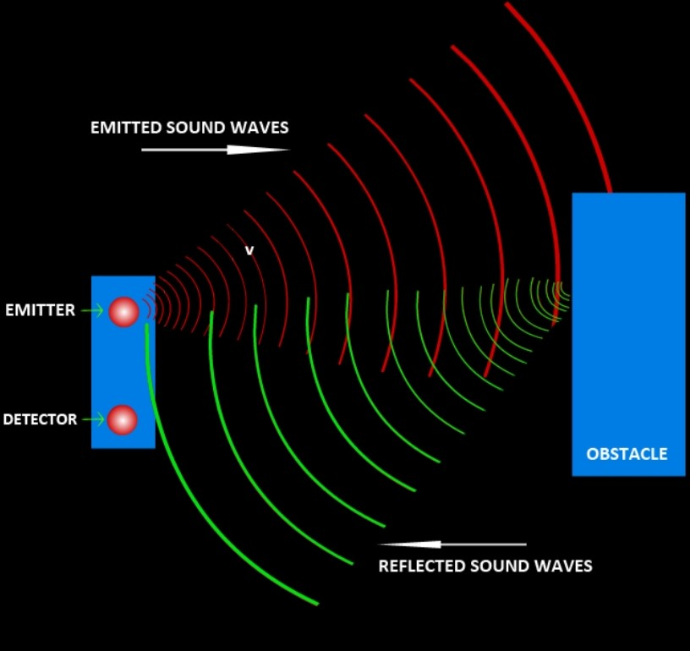

**Fig.1 Ultrasonic sensor diagram**

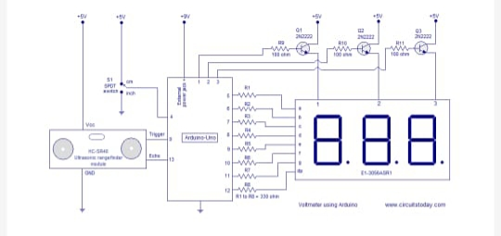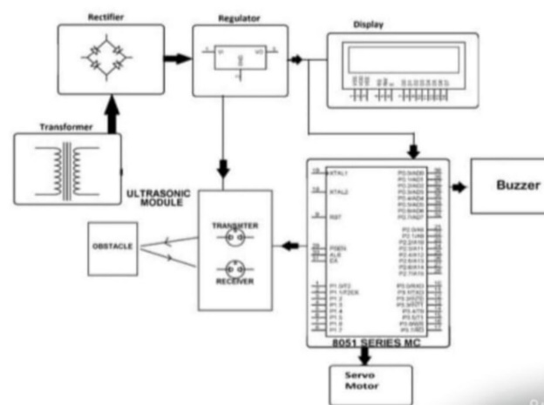

**Fig.2 Circuit connections**

Pg.no 6

**1.3 Working of Ultrasonic Sensor**

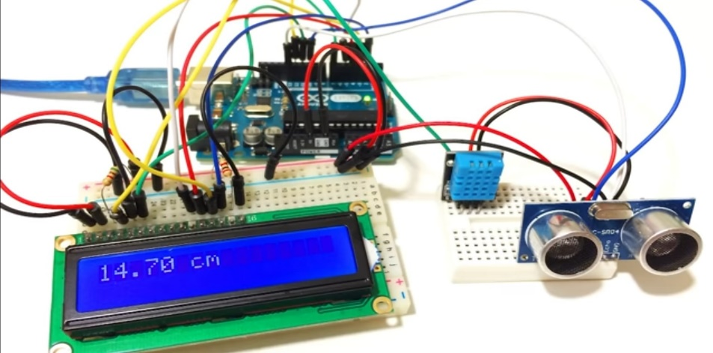

**Fig.3 Ultrasonic sensor**

The ultrasonic sensor works on the principle of SONAR and RADAR system which is used to determine the distance to an object. An ultrasonic sensor generates the high-frequency sound (ultrasound) waves.

An Ultrasonic sensor is an instrument that measures the distance to an object using ultrasonic sound waves. It uses a transducer to send and receive ultrasonic pulses that relay back information about an object’s proximity.

Ultrasonic sensors work by sending out a sound wave at a frequency above range of human hearing. The transducer of the sensor acts as a microphone to receive and send the ultrasonic sound. The sensor determines the distance to a target by measuring time lapses between the sending and receiving of the ultrasonic pulse.

The working principle of this module is simple, it sends an ultrasonic pulse out a 40kHz which travels through the air and if there is an obstacle or object, it will bounce back to the sensor. By calculating the travel time and the speed of sound, the distance is calculated.

Pg.no7

**1.4 How the Ultrasonic Range Finder Measures Distance**

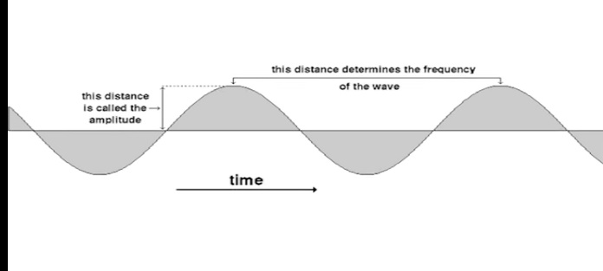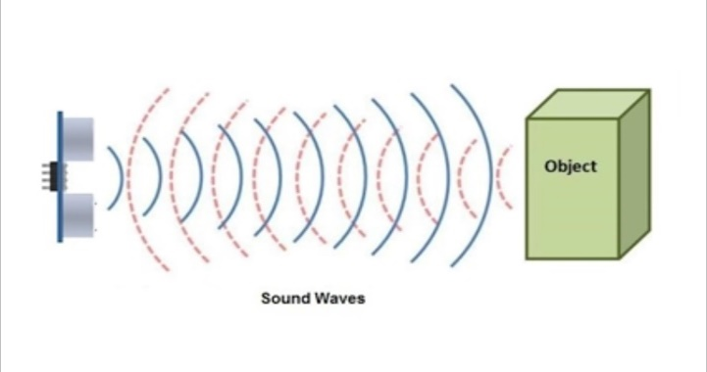

**Fig.4** **The** **Speed of sound**

On the front of the ultrasonic range finder are two metal cylinders. These are transducers. Transducers convert mechanical forces into electrical signals. In the ultrasonic range finder, there is a transmitting transducer and receiving transducer. The transmitting transducer converts an electrical signal into the ultrasonic pulse. If we look at the back of the range that controls the transmitting transducer. Behind the receiving transducer is an IC labelled LM324 This is quad Op Amp that amplifies the signal generated by the receiving transducer onto a signal that strong enough to transmit to the Arduino.

To initiate the distance measurement, we need to send a 5V high signal to the Trig pin at least 10 micro second. When the module receives the signal, it will emit 8 pulses of ultrasonic sound at a frequency of 4KHz from the transmitting transducer. Then it waits and listens at the receiving transducer to the reflected signal. If an object is within the range, the 8 pulses will be reflected back to the sensor. When the pulse hits the receiving transducer, the Echo pin outputs a high voltage signal.

The length of this high voltage signal is equal to the total time the 8 pulses take to travel from the transmitting transducer and back receiving transducer. However, we only want to measure the distance to the object, and not the distance of the path the sound pulse took. Therefore, we divide that time in half to get the time variable in d = s*t. since we know the speed of sound (s), we can solve the equation for distance.

Pg.no 8

**COMPONENTS AND PARTS**

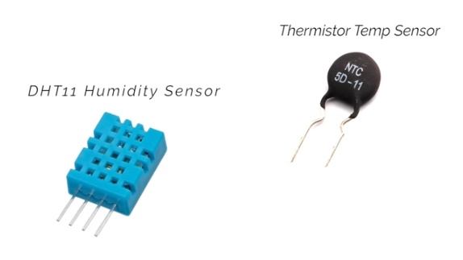 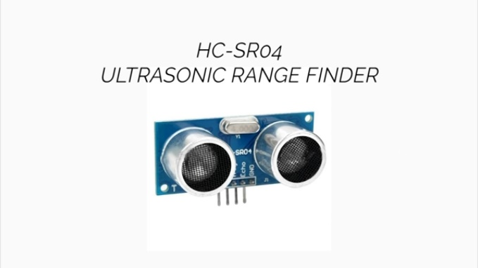

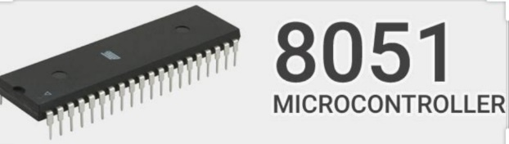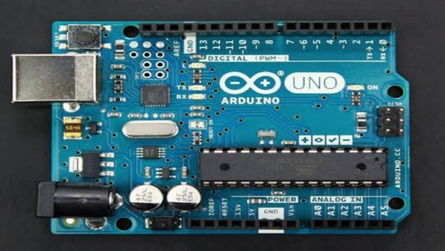 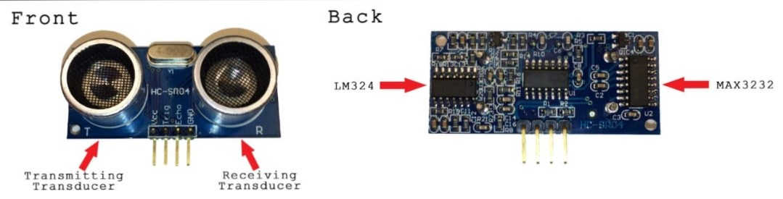

**Fig.5 Spare parts**

The main component required are AT89C51 Microcontrollers- 8051 Programming board, Arduino Uno board, Programming cable, HC – SR 04, Ultrasonic Module, 10 micro F / 16V Electrolytic Capacitor, 2x20 KiloOhm Resistor ( ¼) Watt ), 11.0592 MHz Crystal, 2 x 33pF Capacitor connecting wires, power supply. The software required is Keil micro vision software, proteus, Willar Software. The major components in this project are AT 89C51 Microcontrollers, ultrasonic sensor and LCD display. Here, the SSD is used to display of the object. LCD data pins are connected to the PORT0 of the microcontroller. Here, the SSD is used to display the distance of the object, power supply pins of the microcontroller, SSD and ultrasonic sensor are connected to the 5V DC. Initially burn the program to the microcontroller and give the connection as per circuit diagram. Switch on the board supply. Place the obstacle in front of the ultrasonic module, now you can observe the distance on SSD. switch off the board supply.

Pg.no 9

**2.1 HC-SR04 ULTRASONIC MODULE**

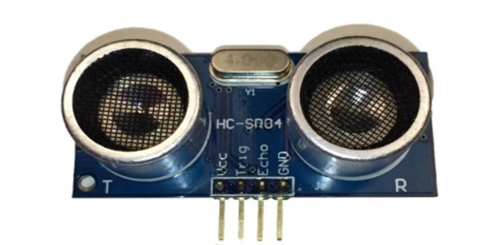

**Fig.6 HC-SR04 Module**

HC-SR04 Ultrasonic sensor module has four pins. Ground, VCC, Trigger and Echo. It as an accuracy of 0.3cm. the sensing range of this module is from 2cm to 5 meter. Working current of this sensor is 15mA and the measuring angle is 15 degree. The Ground and the VCC pins of the module needs to be connected to the Ground and the 5 volts pins on the Arduino board respectively and the trig and echo pins to any digital I/O on the pin of the Arduino board.

1) **VCC:** 5V supply voltage is given to this pin

2) **Trigger:** A 10 microsecondlong pulse is given to this pin for triggering the transmission. Upon receiving a valid trigger pulse, time taken by these pulses to reflect to back is measured and the distance is calculated from it.

3) **Echo:** At this pin the HC-SR04 outputs a signal whose high time is proportional to the range.

4) **Ground:** Ground is connected to this pin

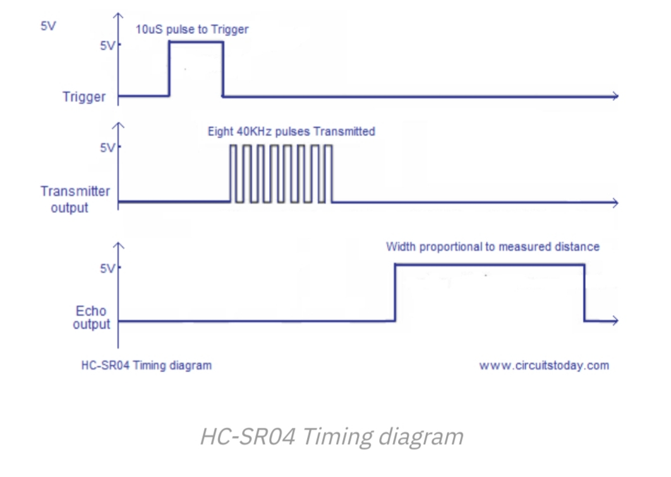 **HC-SR04 timing diagram.**

From the timing diagram, you can see that 40kHz pulse train is transmitted just after 10microsecond triggering pulse and the echo output is obtained. The next triggering pulse can be given only after the echo faded away and this time period is cycle period.

Pg.no 10

**2.2 DHT11 HUMIDITY SENSOR**

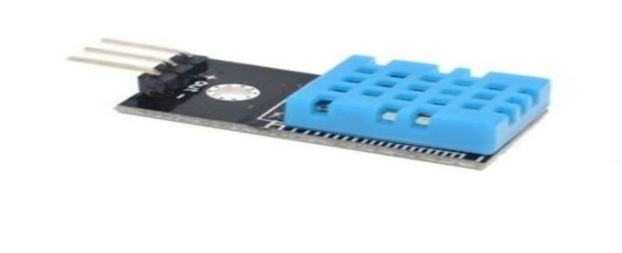

**Fig.7 DHT11 Humidity sensor**

The DHT11 is a basic and ultrasonic low-cost digital temperature and humidity sensor. It calculates the relative humidity by measuring the electrical resistance between two electrons. It uses a capacitive humidity sensor and a thermistor to measure the surrounding air, and spits out a digital signal on the data pin. It is fairly simple to use, but requires careful timing to grab data. The level of humidity in air affects various physical, chemical and biological processes.

**2.3 BREADBOARD**

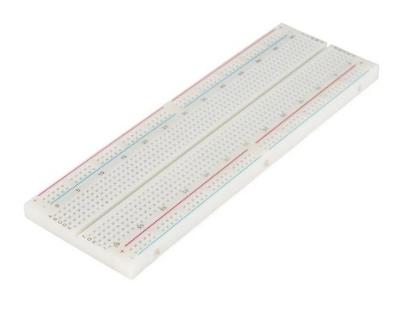

**Fig.8 Breadboard**

A breadboard is construction base for prototyping of electronics. It is commonly used for creating temporary prototypes and experimenting with circuit design. It is easy-to use piece of hardware for wiring electrical circuits. Thus, it made work so easy to create various huge projects, it has become platform to build and test electronic circuit without doing any soldering. The main function of this breadboard is to make quick electrical connections between components like resistors, LEDs, capacitors and various other components etc. certain parts of Breadboard are wired together so that electricity can flow from components to components in orderly rows. Breadboard usually are plugged into standard power supply that either connects to a wall outlet or a battery. Certain holes in breadboard are connected to positive or negative voltage so that when circuit is correctly wired and the breadboard is plugged in, current flows through the circuit. But it is always a good idea to keep it plugged and, if it has power switch, turned off until a circuit is complete to avoid shocks or damaged components.

Pg.no 11

**2.4 LCD ALPHANUMERIC DISPLAY (16X2) AND**

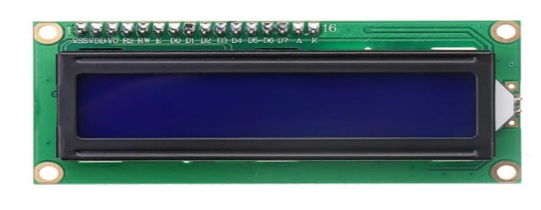 **ITS CONNECTIONS**

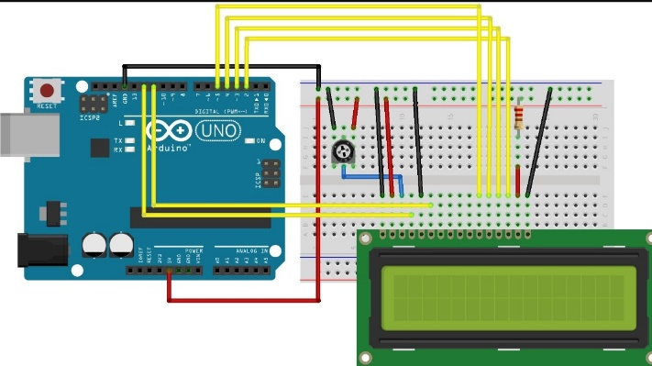

**Fig.9 LCD Display**

Before wiring the LCD screen to our Arduino board we need to solder a pin header strip to the 14 (or 16) pin count connector of the LCD screen, as we you can see in the above image.

To wire our LCD screen to the board, connect the following pins:

LCD VDD pin to Arduino 5V

LCD RS pin to digital pin 12

LCD RW pin to Arduino GND

LCD Enable pin to digital pin 11

LCD D4 pin to digital pin 5

LCD D5 pin to digital pin 4

LCD D6 pin to digital pin 3

LCD D7 pin to digital pin 2

Additionally, wire a 10k Potentiometer to +5V and GND, with it is wiper (output) to LCD screen VO pin (pin3). A 220 ohm resistor is used to power the backlight of the display, usually on pin 15 and 16 of the LCD connector +5V and GND We can even use 220 ohm resistor is used to power the backlight of the display.

Pg.no 12

**2.5 ULTRASONIC RANGE FINDER WITH LCD DISPLAY**

If you want to output the distance measurements to a 16x2 LCD, we need follow this diagram to connect the range finder and LCD to your Arduino:

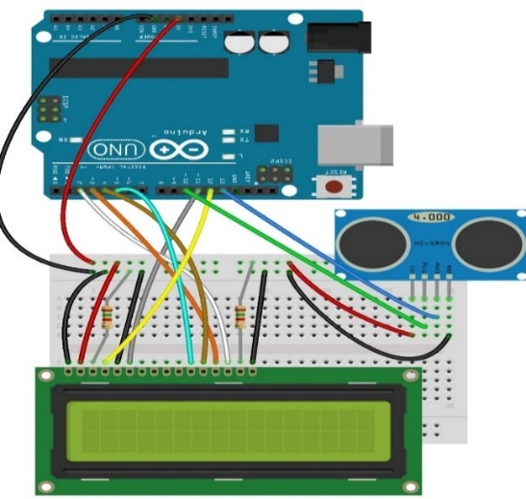

**Fig.10 Ultrasonic range finder circuit**

When everything is connected, we should interface the code to the Arduino:

1. #include <LiquidCrystal.h>
2. #define trigPin 10
3. #define echoPin 13
4. LiquidCrystal lcd(12, 11,5,4,3,2)
5. Void setup() {
6. pinMode trigPin, OUTPUT);
7. pinMode (echoPin, INPUT);
8. }

**A HIGHER ACCURACY ULTRASONIC RANGE FINDER**

Since temperature is a variable in the speed of sound equation above (c **=** 331.4+(0.606xT) +(0.024 x H)), the temperature of the air around the sensor affects our distance measurements. To compensate for this, all we need to add a thermistor to our circuit and input its readings into the equation. This should give our distance measurements greater accuracy. A thermistor is a variable resistor that changes resistance with temperature.

Note: the value of resistor R1 should be equal to the resistance of thermistor

R1= 10K Ohm resistor

Th = 10K Ohm thermistor

Pg.no 13

**SOFTWARE**

Algorithm:

1) Send HIGH pulse for 10 micro seconds on TRIG pin

Initially P3.0=0;

P3.0=1;

Delay ms (10);

P3.0= 1;

2) Wait until the module transmit 40 kHz pulses. When 8th pulse is transmitted echo pin becomes HIGH TIMER 1 starts counting.

3) TIMER1 value is equal to the time taken by the signal to go forward and backward so. We need to take only half time.

4) Distance measured:

* The speed of the ultrasonic pulse is nothing but the speed of the sound which is 340.29m/s.
* Here the timer starts counting from 207D because from datasheet we know that counts 58 corresponding to one cm.
* So here we take count as per 48 and this is done to in order to compensate for the time lags caused by the branching introductions used for the checking the status of P3.0 and P3.1 Pins.
* At 11.0592MHz, TIMER0 gets incremented for 1micro second.

Pg.no 14

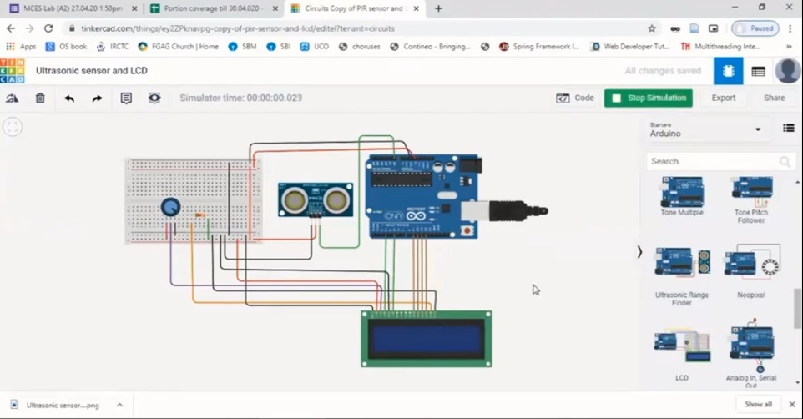**TINKERCAD SOFTWARE TOOL**

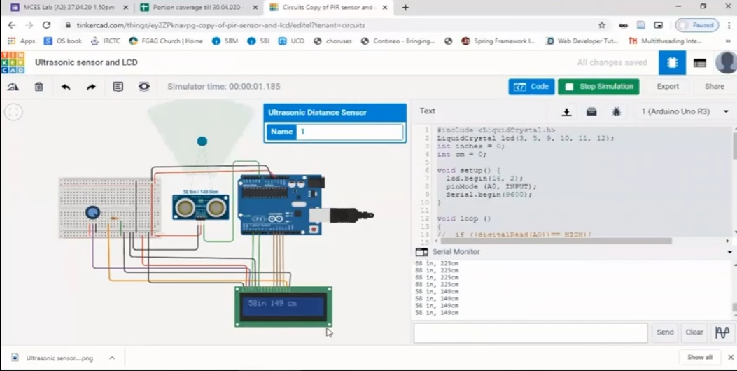

**Fig.11 Interfacing Ultrasonic with LCD**

After the setup of Ultrasonic sensor interfacing with LCD, when we click on simulation button it starts initializing and program starts functioning. It emits a high-frequency sound pulse and calculates the distance depending upon the time taken by the echo signal to travel back after reflecting from the desired target. It detects the speed of sound is 341 meters per second in air. After the distance is calculated, result will be displayed on the LCD display.

Pg.no 15

**PROGRAM:**

Int inches = 0;

Int cm=0;

Long readUltrasonicDistance(int triggerPin, int echoPin)

pinMode(triggerPin, OUTPUT);

digitalWrite(triggerPin, LOW);

delayMicroseconds(2);

digitalWrite(triggerPin, HIGH);

delayMicroseconds(10);

digitalWrite(triggerPin, LOW);

pinMode(echoPin, INPUT);

return pulseIn (echoPin,HIGH);

void setup()

{

serial.begin(9600);

}

void loop()

{

cm = 0.01723 * readUltrasonicDistance(7,7);

Pg. no 16

**CONCLUSION**

This project can be used to measure a distance of 2.5 meters with an accuracy of 1cm. So it can be very well used in detecting various obstacles which are at that distance apart. The use of this can be made to find the distance between the car and the wall for parking purpose and this has also been utilized in hybrid vehicle where in which the hybrid car automatically detects the car and obstacle distance and applies brakes to prevent accidents.

**APPLICATION AND ADVANTAGES**

A) **Advantages**

1) The Ultrasonic sensor has overall high frequency, sensitivity and penetration power therefore, it can easily detect the external or deep objects.

2) The use of ultrasonic sensor makes this range finder more accurate than other methods.

3) This range finder is easy to use not dangerous during operations for nearly objects, person, equipment or material.

B) **Applications**

1) It is used in machines like Automotive parking sensor, obstacle warning systems, terrain monitoring robots, distance measurements.

2) It is used to Vehicle detection for car wash and automotive assembly.

Pg.no 17

**REFERENCE**

1) Data sheet of ultrasonic sensor HC -SR04

2) Muhammad Ali Mazizi, Janice Gillespie Mazizi and Rollin Dr. McKinley, the 8051 f Microcontrollers and the Embedded System using Second Edition

3) B Kretzmer, “Gestures recognition by using ultrasonic range finder based on Arduino Uno”, Proceduce 16th lent conference, Electrical and Electronics Engineering, Aug 2015

4) http:// [www.engineergarage.com](http://www.engineergarage.com)

5) http ://www.basicscircuits.co.in

Pg.no 18